I’m Worried about you…
Dear <<Name>>,
Yes, I really am worried about you. <<Judy>> (our office manager) was checking on our past clients and she realized that it’s been too long since we’ve heard from you at <<your business>.
What Is A Worry Doll?
Worry dolls are traditionally made in Guatemala. A person (usually a child) who cannot sleep due to worrying can express their worries to the doll and place it under their pillow before going to sleep.
According to folklore, the doll is thought to worry in the person's place, thereby permitting the person to sleep peacefully. The person will wake up without their worries, because which have been taken away by the dolls during the night.
Parents may remove the doll during the night, reinforcing the child's belief that the worry is gone. Some parents involve the child in making the dolls to further increase the psychological benefits of releasing worries.

So, we’re giving you the FREE $20.00 <<your company>>Gift Certificate in this letter (It even Doubles to $40.00 with your purchase of $200 or more, and Quadruples to $80 with your purchase of $500 or more)!
Here are 3 Reasons Why Our Competition Hates Us
But You’re Going to Love Us!
- Get Everything You Need To <<insert product/service>>One Phone Call: <<insert benefit #1 of doing business with you. Here’s an example: You’ll save time and money when you make one call to get all of your bags and other packaging, fixtures, display, price marking, anti-shoplifting, even your gift cards, POS System, promotional products, credit card processing, and yes, even your AUTOPILOT customer loyalty program.>>
- You Get Make-You-Happy Client Service:<<insert benefit #2 of doing business with you. Here’s an example: We’re so serious about giving you Make-You-Happy Client service that we own www.MakeYouHappy.com worldwide! It actually is very simple. Everyone here knows Only Happy Clients Come Back...and our job is to be sure you are happy - every time!)>>
- You Get Your Order On Time - Every Time: <<insert benefit #3 of doing business with you. Here’s an example: Within minutes of placing your order it will be pulled and ready for shipment. If you place your order on stock product before 2 PM, it will ship that day, and if you place it later and tell us you need it right away, we’ll do our best to get it out that day. And when you order something that is non-stock or custom printed, you’ll get it when you’re told you will - EVERY TIME!)>>
$20.00 <<your company>>Gift Certificate in this letter. It even Doubles to $40.00 with your purchase of $200 or more, and Quadruples to $80 with your purchase of $500 or more!


HURRY! Offer Expires <<insert date>>!
Bu you have to call by <<DATE>> to get in on this great opportunity. Call 000-000-0000 to schedule your next appointment and mention that you received the worry doll and you’ll get a $20.00 <<your company>>Gift Certificate in this letter (It even Doubles to $40.00 with your purchase of $200 or more, and Quadruples to $80 with your purchase of $500 or more)!
Sincerely,
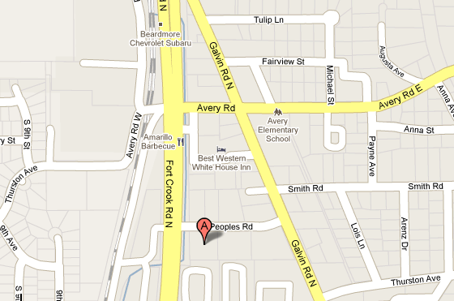
John Doe
<<YOUR COMPANY>>
P.S. Hurry and call today so we can reconnect! We really do miss you! This great offer is only available until <<DATE>> so be sure to call 000-000-0000 today!
P.P.S. If a friend or family member could use our services as well, just give them a copy of this letter and tell them to call 000-000-0000 and we’ll be sure they get the same offer as you!
Your logo, letter head, etc with hours, location, phone and contact information.

